**ADVANCED DATABASE SYSTEMS- PRAC 1**

**Task:2**

**Semi Join**

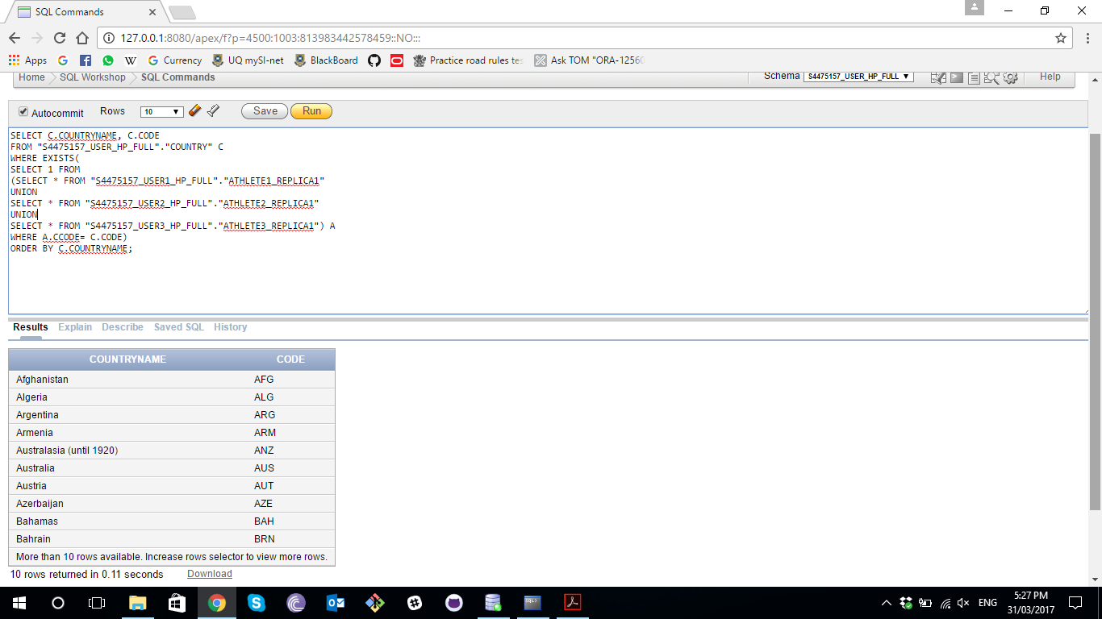

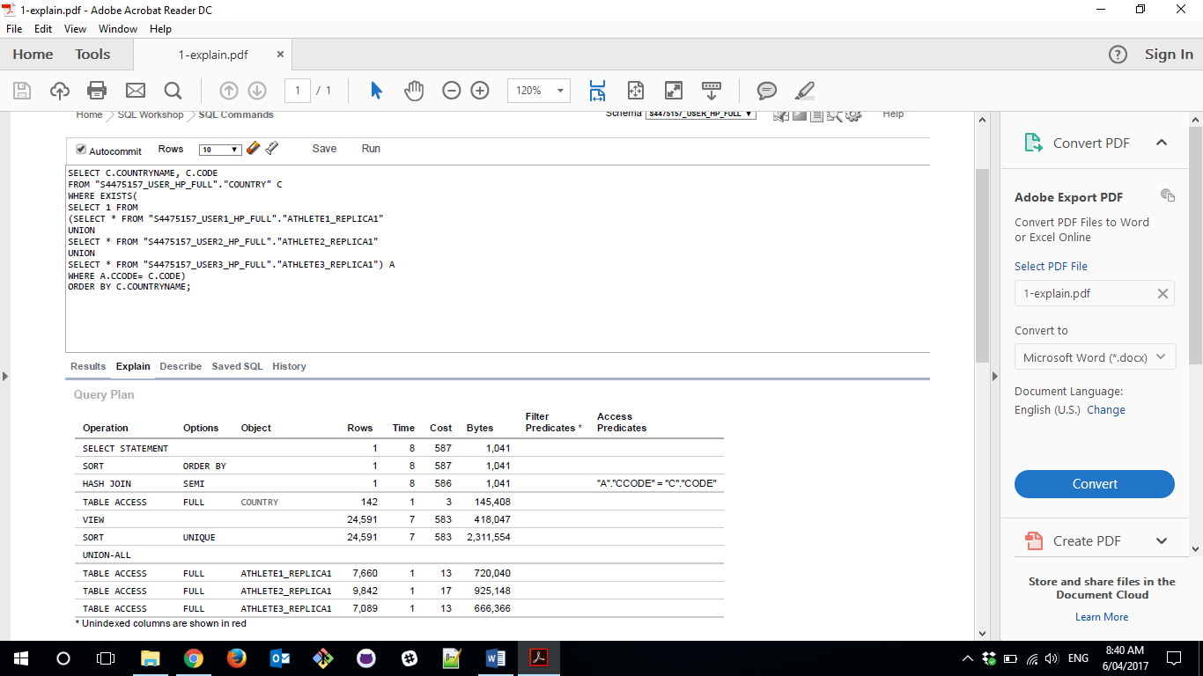

**Inner Join**

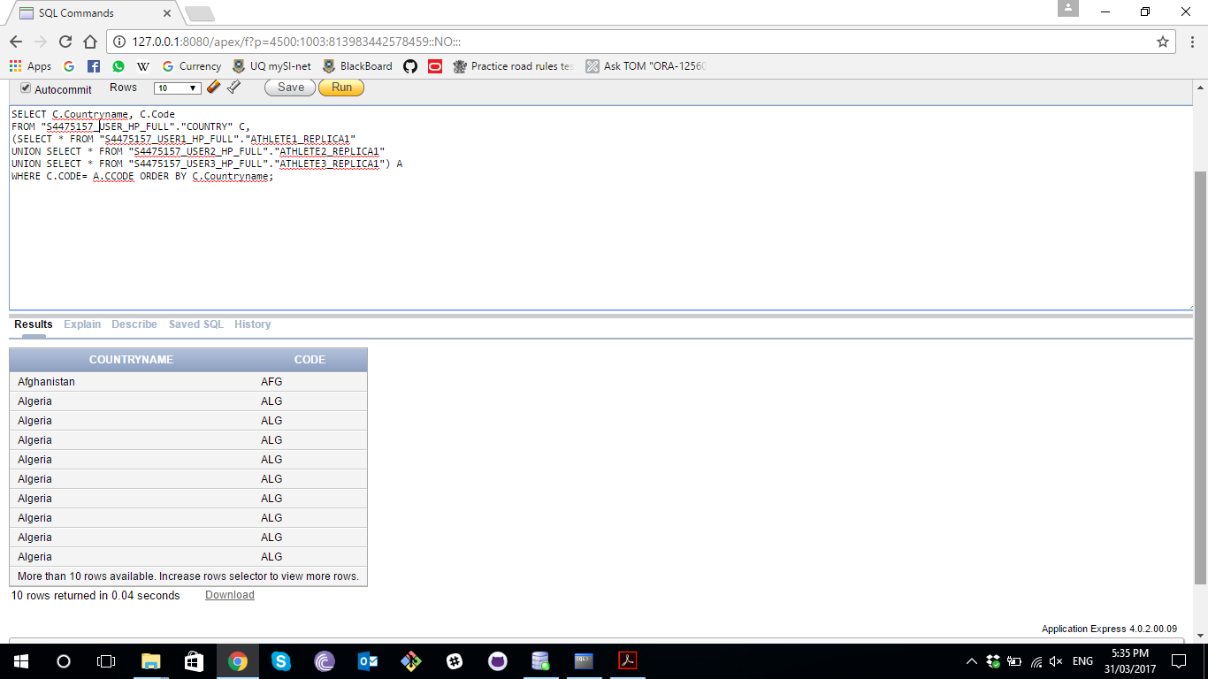

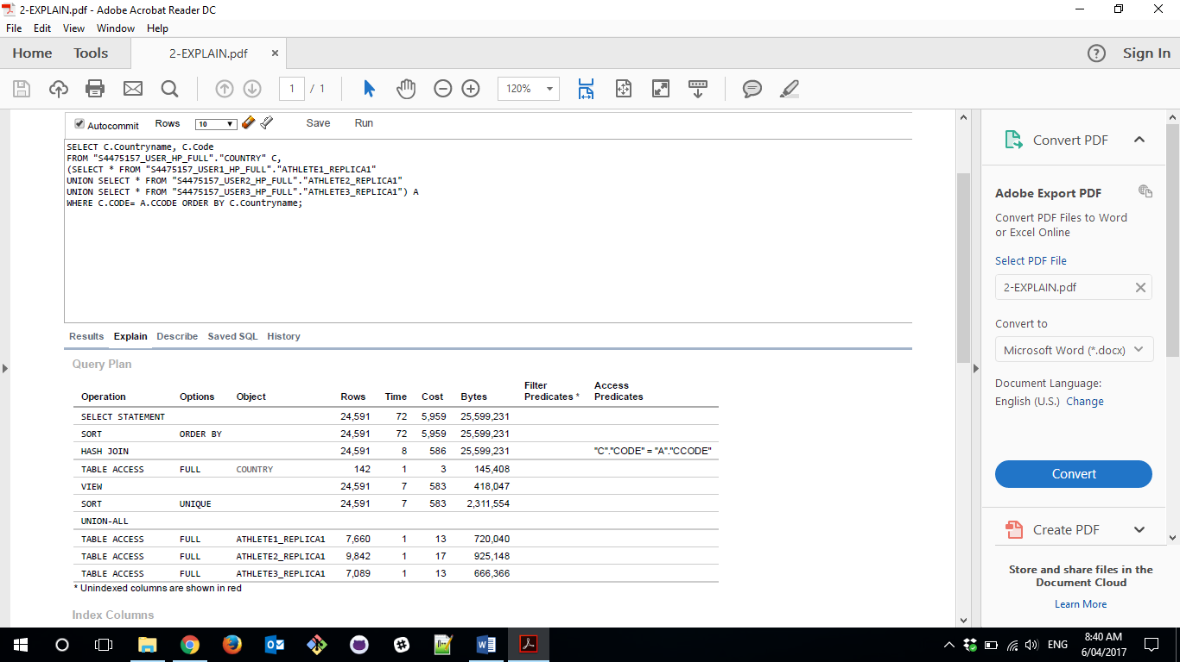

**Task:3**

**Step One**

Get all the Athletes whose nationality is Australia from Athlete_V2

**select** AthleteID **from** "s4475157_USER2_VP"**.**"ATHLETE_V2" **where** CCODE**=**'AUS'**;**

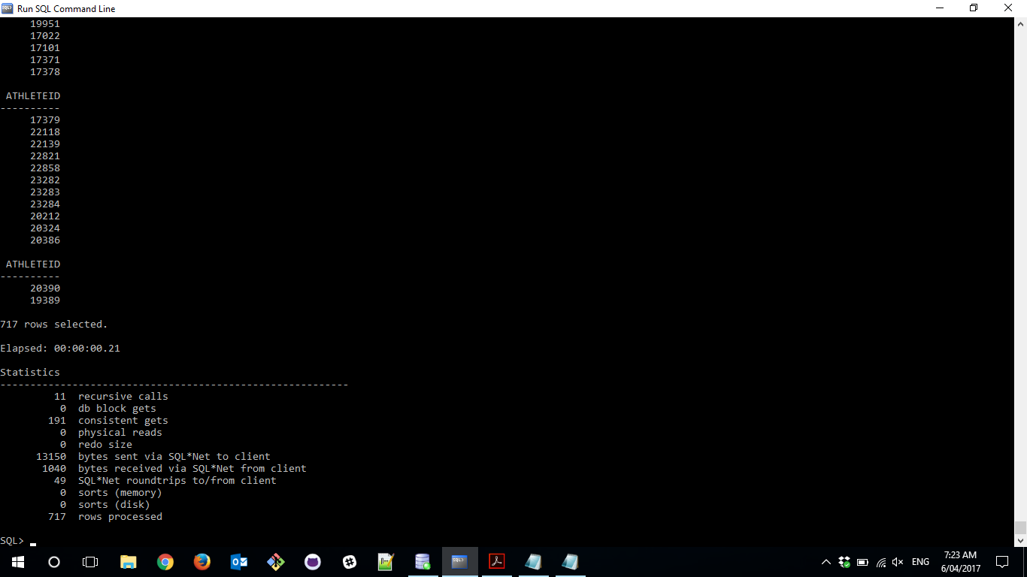

**Step Two**

Use the results above to make a query to select all the related data from Athlete_V1

**select * from** "S4475157_USER1_VP"**.**"ATHLETE_V1" a **where** a**.**AthleteID **in**

**(select** AthleteID **from** "S4475157_USER2_VP"**.**"ATHLETE_V2" **where** CCODE**=**'AUS'**);**

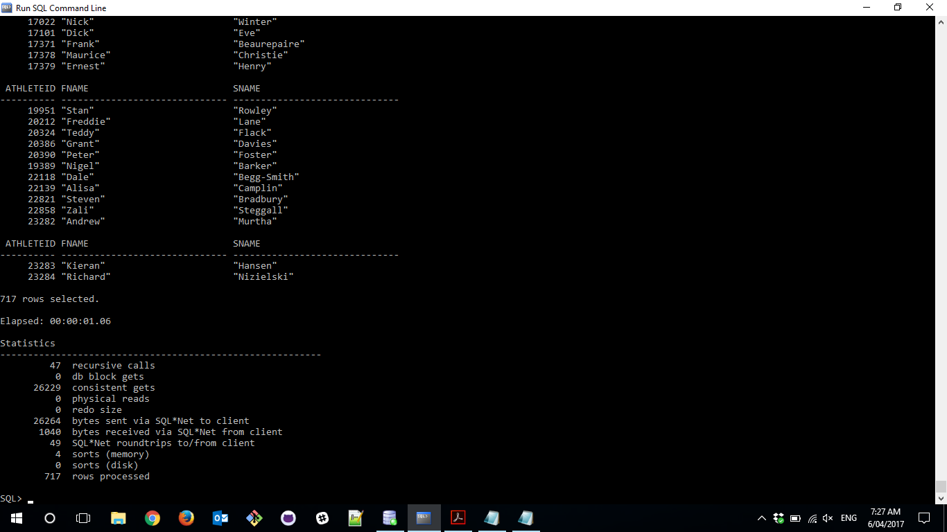

**Step Three**

Get the rest of the athlete details

**SELECT b.AthleteID, b.FName, b.SName, c.BDate, c.CCode, c.SportID**

**FROM** "S4475157_USER2_VP"**.**"ATHLETE_V2" c**,**

**(SELECT \***

**FROM** "S4475157_USER1_VP"**.**"ATHLETE_V1" a

**WHERE a.AthleteID IN (SELECT AthleteID**

**FROM** "S4475157_USER2_VP"**.**"ATHLETE_V2"

**WHERE CCODE = 'AUS')) b**

**WHERE b.AthleteID = c.AthleteID;**

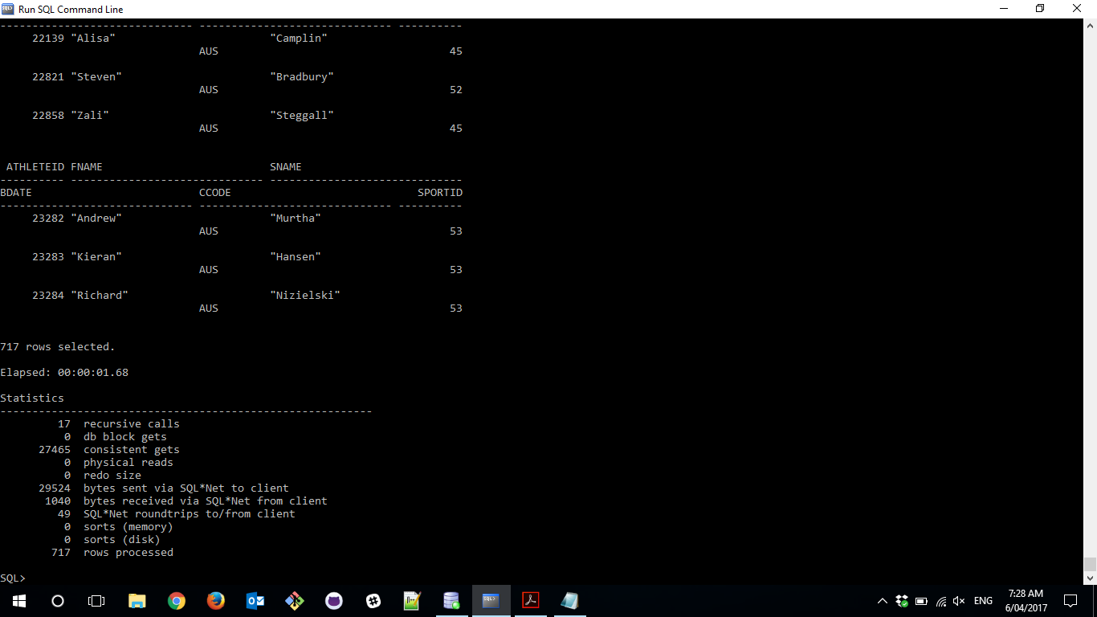

**Step Four**

**Compare with a traditional inner-join query**

**select b.AthleteID, b.FName, b.SName, c.BDate, c.CCode, c.SportID**

**from**"S4475157_USER1_VP"**.**"ATHLETE_V1"b, "S4475157_USER2_VP"**.**"ATHLETE_V2" c

**where b.AthleteID= c.AthleteID;**

